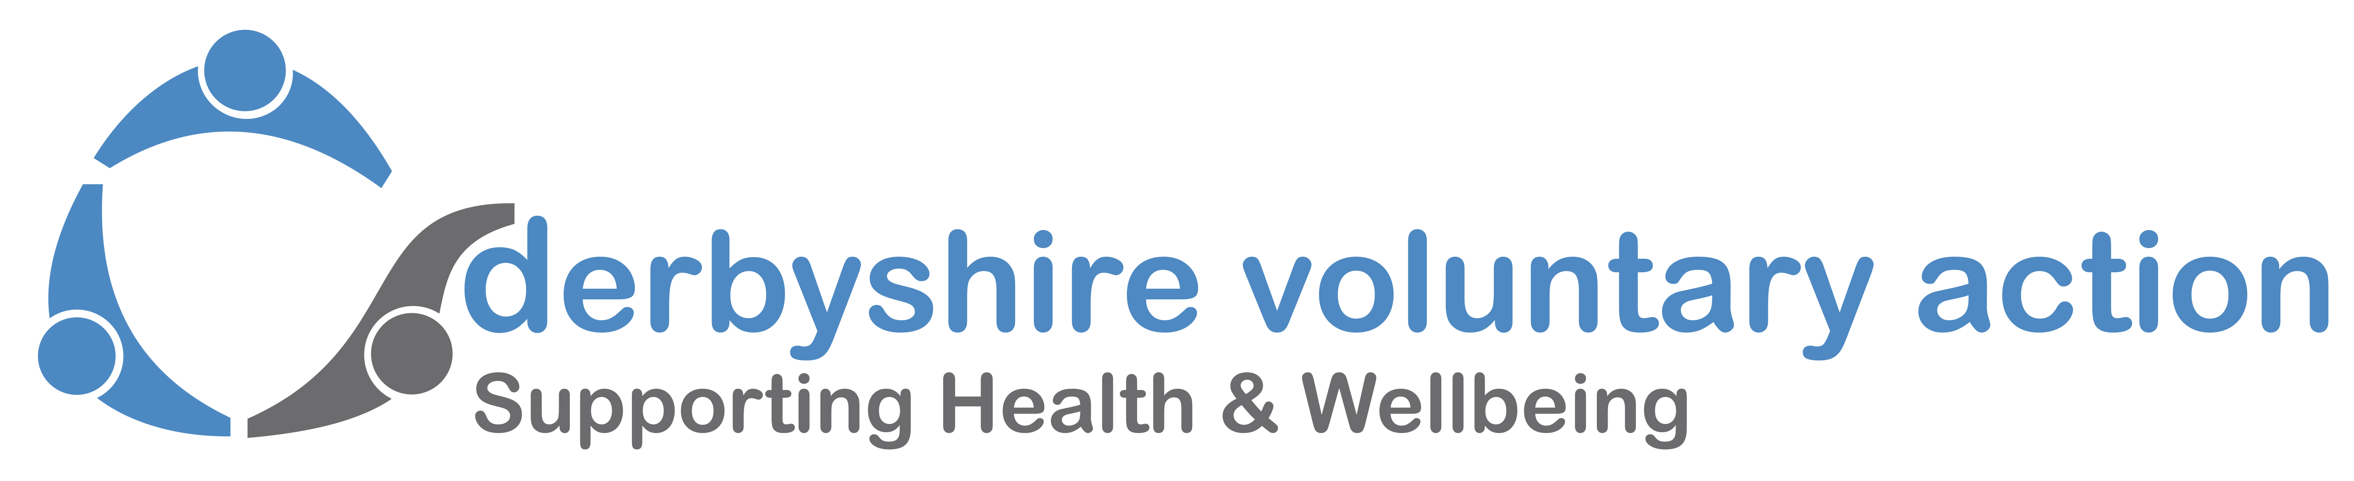
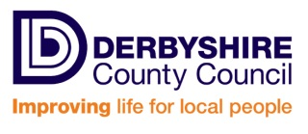
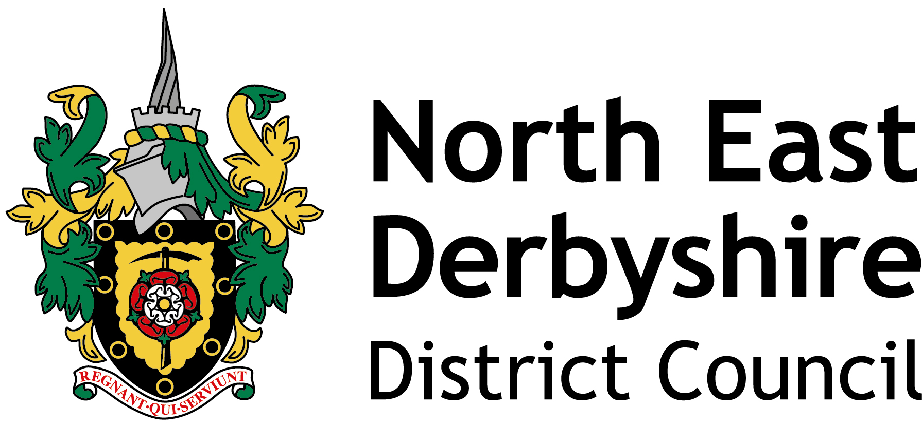

Healthy North East Derbyshire Partnership
Small Grants Scheme Guidance Notes
Introduction
The Healthy North East Derbyshire Partnership works with a wide range of organisations to address identified health needs of people and communities across the district.
It is committed to building, promoting and supporting the health and wellbeing of local people and has set out its priorities and local actions in the Healthy North East Derbyshire Partnership Locality Public Health Plan for 2019-20.
To meet its objective to build social capital, one of its key actions is to provide a Small Grants Fund to voluntary and community sector groups who are making a positive difference to the health of people across North East Derbyshire District.
Development of Social Capital is a key objective for the Partnership and one of four key priorities of the Derbyshire Health and Wellbeing Board.
Applications will need to support the development of Social Capital.
Priority will be given to new projects or to enhance existing projects.

How much can you apply for?
Grant funding of up to £1,000 per applicant is available, and must be spent within 12 months of receiving the grant.

Who can apply?
Any voluntary/community groups or local people within the North East Derbyshire District Council (NEDDC) area (see map below), who come together to support the health and wellbeing of their community are eligible to apply.

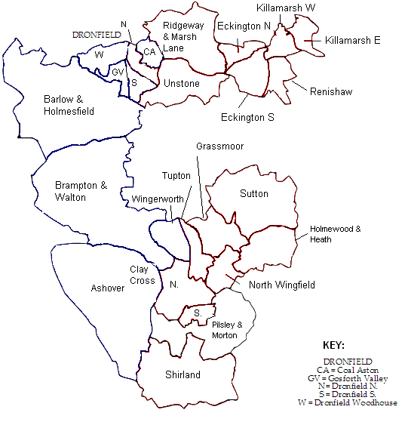

For example, your group might be a luncheon club, a social group, a self-help group or another type of community group that provides help and support. You might want to set up a new group to meet a local need that’s currently not being addressed.

Projects should aim to meet one or more of the following criteria:
1. Overarching priority for North East Derbyshire: older people, long term conditions and independence in the home
2. Build Social Capital
3 Improving the quality of life for carers
4. Reducing the impact of external wider determinants on health and wellbeing
5. Promoting positive mental well-being and reducing social isolation
6. Support the emotional health and well-being of children and young people
7. Increasing physical activity
8. Assisting people who live with a limiting long term illness or disability (including reducing frailty)
9. Support the Integrated Care Agenda to reduce hospital admissions
10. Reduce the high incidence of hospital stays as a result of self-harm and alcohol related harm

What sort of projects are eligible?
Projects should:
- Be delivered in, and support the residents of North East Derbyshire
- Link directly to the North East Derbyshire priorities
- Be new and fill a gap in service provision, or add value to existing provision
- Seek to continue the activity after the funded project ends, if appropriate
- Build social capital
- Support mental health

We would expect to see:
- Clear evidence of community benefit
- Evidence of community involvement, where appropriate

What sort of activities does the Small Grants Scheme support?

Ideas could include:
- befriending/buddying
- Activities that support isolated people
- Activities that help improve mental health and wellbeing
- Financial projects e.g. that help people manage their money better
- setting up a sports team or organising a community sporting event
- setting up or extending services offered by an existing luncheon/social club
- a cookery/shopping network
- a community garden or growing scheme
- a health related community event

Please note that this Small Grant Scheme cannot fund:

- Core staff salaries, although the Panel may consider staff costs which are specific to the activity/project.
- Organisational running costs (The Healthy North East Derbyshire Partnership Small Grants Scheme is specifically for community/social capital activities and projects). If your group supports health and care/wellbeing and you are struggling with running costs i.e. room hire, insurance etc. please speak to Derbyshire Voluntary Action about applying to the Derbyshire Voluntary Action Small Grant Scheme by calling 01246 555908 or emailing kim@dva.org.uk
What do you need to show on your application form?
- Why your project is needed and the health outcomes you expect to achieve.
- Clear evidence of the impact on the health and wellbeing of the local community.
- Demonstrate how your project will deliver/support residents living in North East Derbyshire District
- Clear evidence of how you will promote community involvement and reach out to the local community, particularly from local people who would not normally be included in the groups’ activities.
- How the project will seek to continue after the funding period (if applicable)
- Clear evidence of how the project will support the concept of Social Capital.

Definition: Social Capital is about the relationships, networks and trust which help people to support each other, build confidence, and create the opportunities to bring about change in their lives and communities.

There is strong evidence that links the presence of Social Capital in communities with improved health outcomes.

Monitoring and Evaluation
As a condition of funding, all successful applicants will be expected to complete a short End of Project Report on the impact of their project. This will be provided with the Decision Letter if you are successful and will provide guidance on the type of information we are looking for. This report must be returned to Derbyshire Voluntary Action at the end of the funded project/activity and demonstrate that the funding was used for the purpose it was intended. This information will allow the Health and Wellbeing Partnership to assess the impact and overall effectiveness of projects for future funding.

Process
Completed application forms (with all supporting documentation) should be submitted to Derbyshire Voluntary Action by the closing date.

A grant panel comprising of Derbyshire Voluntary Action, Public Health, and representatives from the Healthy North East Derbyshire Partnership will assess each application and applicants will be notified whether successful or not shortly after.

If you are a formal constituted group or a group with working rules payment will be made to the successful applicants by BACS within 2 weeks of the panel’s meeting.
If you are not a formal constituted group or a group with working rules Derbyshire Voluntary Action will reimburse you for receipted expenditure or process invoices on your behalf.

On completion of the project, successful applicants will be required to submit their End of Project Report.

The grant scheme will be administered by Derbyshire Voluntary Action.
If you would like any help completing this application form you can contact Sandra Pink, Advice & Project Manager, Links CVS (The Chesterfield and North East Derbyshire Council for Voluntary Service and Action Limited) Tel: 01246 274844 Email: sandra.pink@linkscvs.org.uk

During the COVID19 crisis, applications can be submitted at any time. We will aim to give a decision within two weeks of receipt of application. The application window will be paused or closed if necessary.

Applications should be to:Derbyshire Voluntary Action, Offices 2a -2c, The Market Hall Chesterfield S40 1AR or email kim@dva.org.uk

