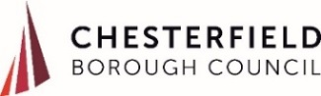
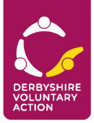
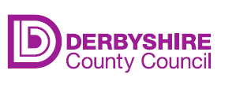
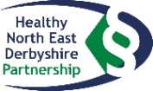

Feeling Connected in North East Derbyshire and Chesterfield
Social Connectedness Action Plan
‘Feeling Connected Fund’
Call for Proposals
Projects in the range £501-£5,000
Submit by noon on Monday 7 December to julia@dva.org.uk
What is the Feeling Connected Fund for?
The aim of the Feeling Connected Fund is to fund work in the community that will help to break down the barriers people experience which stop them from feeling connected to others.
The three priorities identified within the Social Connectedness Action Plan for North East Derbyshire and Chesterfield are:
- Digital Divide
In recent months we’ve seen a huge increase in digital interaction. With 7 in 10 people making at least one video call a week, including growing numbers of older people, digital technology has been a lifeline for many during lockdown. But we know that many people are still not online – especially people who were already lonely or isolated before Covid-19 struck. Lockdown threw into sharp definition the issue of digital exclusion, which has been a reality for many people who lack basic digital skills since long before the pandemic.
- Confidence to Connect
In a survey of residents carried out earlier this year, almost 25% of respondents said that that they didn’t have the confidence to make new connections with others, and it’s fair to assume this percentage will have increased. We would like to hear your ideas about initiatives that build confidence and enable isolated and lonely people to feel able to reach out to create new connections.
- Young People
Evidence collected in the early summer suggested that 50% of 16-24 year-olds experienced ‘lockdown loneliness.’ This could be a consequence of the loss of peer group support during this important developmental stage where peer interaction is important for mental health and wellbeing.
The Social Connectedness Action Group wants to commission new project work in North East Derbyshire and Chesterfield which will address one or more of these three priorities over the coming 12 months.
Please send a short proposal (no more than 2 sides of A4) outlining:
- WHAT: a description of the work you would like to do
- WHERE: where your work will take place
- WHO: the people who will benefit from your work (a community of interest or a geographical community).
- HOW MANY: the number of people your proposed project will help.
- WHEN: start and finish dates
- HOW MUCH: an outline budget of the funds you need to enable your project to happen.
- WHICH PRIORITY: which of the three priorities your project will address
- OPPORTUNITY TO WORK IN PARTNERSHIP WITH OTHERS: detail any opportunities for joining up your work with the work of others.
Send in your proposal at any time over the next four weeks (from 9 November to 7 December) to: julia@dva.org.uk. Our Social Connectedness Funding Panel will look at the first tranche on Monday 23 November and the second tranche on Monday 7 December. We’ll follow up the proposal with a more in-depth discussion with the applicants we are able to support, and put in place a short service-level agreement for the delivery of the work.
For more information contact Julia Cook on 07716 737397 / 01246 555908.

