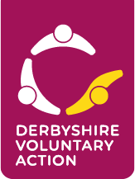

DERBYSHIRE VOLUNTARY ACTION
HEALTH AND WELLBEING GRANT 2024

GUIDANCE FOR APPLICANTS
PLEASE READ THIS GUIDANCE BEFORE BEGINNING YOUR APPLICATION
Please note: Applications can be submitted up to and including 31 May 2024.

Introduction
In the financial year 2024-25, Derbyshire County Council Public Health have made available funding to Derbyshire Voluntary Action, which it will administer as a ‘Health and Wellbeing Grant’ for Chesterfield, North East Derbyshire, and Bolsover.

The purpose of the Health and Wellbeing Grant is to support new or existing not-for-profit voluntary and community groups/organisations whose work strengthens the local community and improves the health and wellbeing of their beneficiaries.

What type of costs will the fund support?
 | What? | Where? | How Much?
1. Project and activity costs  Additional one-off costs which are over and above the group’s general running costs. This expenditure relates to a particular project or activity the group would like to run in the next 12 months. | Examples could include:  - Materials or resources needed for an activity.  - Costs associated with a special event.  - Sessional worker to lead a workshop. | Bolsover  Chesterfield  North East Derbyshire | Up to £1,000 in each area

There are four elements to the funding available:
- Financial Inclusion
- Mental Health & Wellbeing
- Social Connectedness
This element can fund face to face and digital connections to be made.
- Children and Young People ages 0-18 years old
This element is split into 3 categories:
- 0-5-year-olds
- 6-11-year-olds
- 12-18-year-olds
Please note:
- Category 1 (0-5 years), we ask that your project delivers to at least one of the
three further sub-categories:
- Ready for Nursery
- Speech & Language
- Motor Skills & Physical Activity
- Categories 2 and 3, Applications will be accepted without further restrictions, for any appropriate health and wellbeing related activity aimed at young people.

Issues that we want to address through this fund:

We are interested in applications that can demonstrate that they will:

- Strengthen the local community, help build social connections and reduce loneliness.
- Benefit the health of people of all ages, in particular children and families and/or older people.
- Promote good mental health and emotional wellbeing.

Projects could help to develop and promote: -

- social connections
- a sense of belonging
- a sense of purpose
- reduction in stress and anxiety
- improved mental wellbeing
- play, exercise, and physical activity
- healthy eating

Please bear in mind, the grants panel will look less favourably on applications where:

- There is no evidence that the applicant has made any effort to estimate the costs accurately.
- There is no evidence of need.
In addition:
- The grant awarded must be spent within 12 months.

- We will not make awards retrospectively – you cannot apply for funding to pay for something that has already taken place or has been paid for.
- We do not pay professional fees such as solicitors or accountants.
- We don’t usually make a grant that would be a small contribution towards a large project,
- We prioritise applications that support health and wellbeing inequalities.

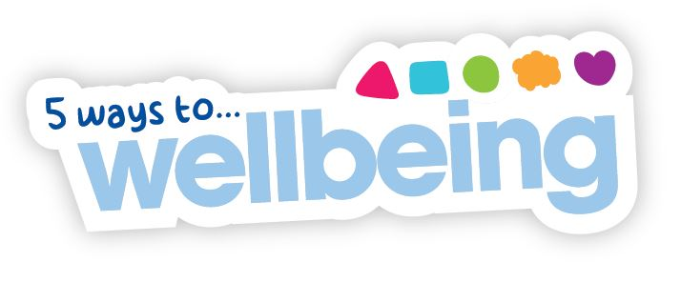
We want to embed the Five Ways to Wellbeing into all the community work we support. These are: Give; Take Notice; Connect; Keep Learning; Be Active.

- As an organisation receiving funding from us, we ask for your pledge to raise awareness of the Five Ways to Wellbeing.

- You can find more information on the Five Ways to Wellbeing here:

- https://www.derbyshire.gov.uk/social-health/health-and-wellbeing/mental-health-and-wellbeing/five-ways-to-wellbeing/five-ways-to-wellbeing.aspx

- https://www.nhs.uk/mental-health/self-help/guides-tools-and-activities/five-steps-to-mental-wellbeing/

On the application form we ask you to give us a short description on how you will incorporate one or more of the 5 Ways to Wellbeing into the activity the grant will fund - and how you will promote it to your participants or beneficiaries. This could be something as simple as sharing some posts about it on social media, using the logo on your publicity leaflet or talking about it with your group members.

Who can apply?

To apply for this fund your group must fit these criteria:

- Be a non-profit making voluntary sector organisation or community group that is based in and/or runs activities in Bolsover, Chesterfield, or North East Derbyshire.
- Have a management committee.
- Have a bank account in the name of the organisation.
- Have a constitution or other form of governing document (working rules).
- Be able to demonstrate a need for financial assistance and provide copies of the latest signed accounts. –If you are a new group and do not have a set of accounts then we will accept your latest financial statement.

In the case of a newly established group, you must be able to show that you have plans to put the things mentioned above in place.

The applicant must have appropriate and adequate insurance for the group or activity, as well as the relevant policies associated with running the group or activity. If a third party has said they will insure your project, we will need to see written confirmation of this before any award can be agreed.

We want to encourage applications from voluntary and community groups as this is what all the funds are intended to support. However, we understand that for some projects such as community playgrounds, a play area, or an annual village celebration then it may be more appropriate for a community venue, residents’ association, or Parish Council to be the applicant.

Who can’t apply?

Public or Business Sector bodies/organisations.

How often can I apply?

You can send in one application up to and including 31 May 2024.

Priority will be given to those that can demonstrate a current and pressing need for the funding.

How to apply:

Applications can be submitted up to and including 31 May 2024.
Please note: All applications received will be forwarded to the panel for their consideration after 31 May 2024. You will be notified of the outcome of your application as soon as possible once a decision has been made.

- Please visit the Derbyshire Voluntary Action website: https://dva.org.uk/#
and download an electronic copy of the application form.

- Please contact our Finance and Grants Administrator, Kim Gosling: kim@dva.org.uk
or call 07546 023161 for an electronic application form.

- Alternatively, a paper copy can be sent to you by post.

The form and guidelines can be made available in large print or on audio.

Completed Application Forms can be sent to us by:

EMAIL: You can send your application by email with your constitution, accounts and any quotes or supplementary information as attachments.
Please send to kim@dva.org.uk

POST: Kim Gosling, Derbyshire Voluntary Action, 3rd Floor, Dents Chambers, 81 New Square, Chesterfield S40 1AH. Please allow plenty of time for your application to be received before 31 May 2024.
Mark the envelope ‘Health and Wellbeing Grant Application’ and please ensure that you use the correct postage.

Please don’t hesitate to ask if you would like advice about whether you / your group is eligible for a grant, or if you would like support in completing the form.
You can email kim@dva.org.uk or call 07546 023161.

The grants panel is made up of staff and trustees from Derbyshire Voluntary Action; staff from Derbyshire County Council Public Health; and representatives of Bolsover, Chesterfield, and North East Derbyshire Locality Health Partnerships.

Conditions that apply:

Please be aware that: -

- Your contact details may be shared with stakeholders (NHS Derby and Derbyshire Clinical Commissioning Group and Derbyshire County Council Public Health and members of the grants panel).
- Derbyshire Voluntary Action reserves the right to request further information, not specified on the application form.
- All successful applicants are required to return an End of Grant Evaluation Form
  - failure to complete and return this may mean that your group will have to repay the grant.
  - failure to complete and return an evaluation, without good reason, will mean your group is not eligible to apply in the future.

- the applicant must have all consents required for the grant project to proceed.

- the applicant shall maintain full and proper insurance policies relevant to the grant activity and shall provide evidence of such insurance on request.
- the giving of this grant may be publicised by Derbyshire Voluntary Action and other stakeholders.
- When publicising your group or activity please let people know that you have been supported by a grant from Derbyshire Voluntary Action by quoting our name or displaying our logo on publicity materials.
If, during your planned project/activities you find that you would like to spend the grant differently then you must contact Derbyshire Voluntary Action (kim@dva.org.uk), to seek approval before going ahead.

