Derbyshire Community Hub Network Grant
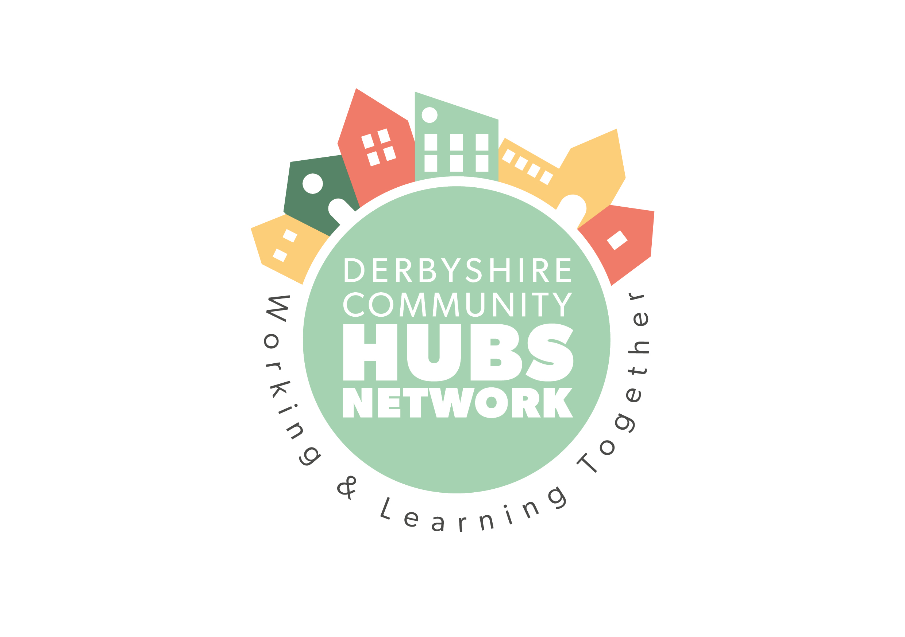
Application Guidelines
Grant Purpose:
This grant aims to support projects that enhance existing community hubs or create new ones, fostering community engagement and support.
Grant Amount:
Up to £5,000
Eligibility Criteria:
- The applicant must be a not-for-profit organisation.
- The project must aim to enhance an existing community hub or support the creation of a new one.
- The project should demonstrate clear benefits individuals using the community hub, and to the local community.
Application Sections:
- Applicant Information:
  - Organisation Name:
  - Contact Person:
  - Address:
  - Phone Number:
  - Email Address:
  - Not-for-Profit Status: (Please provide proof of status)
- Project Description:
  - Brief Description of the Project: (Please provide a summary of the project, including its purpose and main activities)
- Project Objectives:
  - What are the main objectives of the project? (Please list the specific goals you aim to achieve)
- Community Impact:
  - Please underline the location the community Hub is based in.
  - Number of New People to be Supported: (Estimate the number of new individuals who will benefit from the project)
  - How will the project benefit the community? (Describe the expected positive outcomes for individuals and the local community)
For example, below are a few ideas you might include about how the grant might support the hub to increase its ability to provide outcomes (or if a new hub; to develop):
  - A welcoming and inclusive space for individuals who are lonely and isolated. How will it help them build meaningful connections and reduce feelings of loneliness.
  - Increase in-house initiatives that improve physical health, mental resilience, and overall wellbeing.
  - Offer workshops and training sessions to build self-esteem, develop new skills, and inspire personal growth for those lacking confidence or aspiration. How will these opportunities empower individuals to set and achieve personal goals.
  - Develop health and wellbeing initiatives for individuals with poor physical or mental health.
  - Provide a safe and supportive environment where individuals can access the resources and support, they need to thrive.
  - Link people to external social, creative and wellbeing activities for example, local VCSE wellbeing services, mental health support groups, and wellness workshops, crafting, social events, fitness classes and other community based activities.
  - Increase its ability to be an active member of the Derbyshire Community Hubs Network
- Budget Costing:
  - Total Project Cost:
  - Amount Requested from the Grant:
  - Detailed Budget Breakdown: (Please provide an itemised list of expenses and their costs). Costs over £100 will require a quote.
- Project Timeline:
  - Start Date:
  - End Date: if applicable.
  - Key Milestones: (List the major steps and their expected completion dates)
- Sustainability:
  - How will the project be sustained after the grant period ends? (Describe any plans for ongoing funding or support)
- Governance Details:
Please give details of …
  - Management Committee: (Identify how many and who the members are)
  - Constitution/working rules: (Do you have a constitution or working rules)
  - Insurance: (Do you have a current Public Liability insurance policy)
- Return Information:
  - Please return the completed application form to:
- Address: Derbyshire Voluntary Action, 3rd Floor Dents Chambers, 81 New Square, Chesterfield S40 1AH (please mark for the attention of Clare Gage)
    - Email: hubs@dva.org.uk
    - Deadline for Submission: Friday 20th December 2024

Additional Information:
- Applications will be reviewed based on the project’s feasibility, community impact, and alignment with the grant’s objectives.
- Successful applicants will be required to submit a final report detailing the project’s outcomes and financial expenditure.
Contact Information: For any questions or further information, please contact:
- Name: Clare Gage
- Phone Number: 01246 555908
- Email Address: hubs@dva.org.uk

