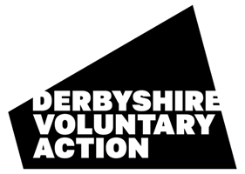
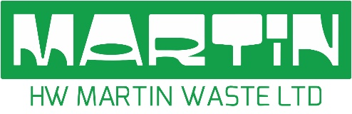


Derbyshire Grant – Funded by Bolsover Reuse Shop
2026–2027

Application Form
Thank you for your interest in this grant fund. This application form helps us understand your project idea. Please keep your answers brief and clear.
BEFORE YOU APPLY - Please read through the Guidance Notes. This will help you to answer each question appropriately.

SECTION 1: About You
Name of Organisation/Group
Contact Name
Email
Address
Phone Number
Describe your Organisation/Group
Is your organisation or group formally constituted? | Yes ☐  Please provide a signed copy of your constitution of governing documents. | No ☐
Bank Details:  The account should be the group’s name. We cannot make payments to individuals. | Account name:
 | Account number:
 | Sort code:
Do you have public liability insurance? | YES  (please provide a copy of your insurance policy)
Do you have public liability insurance? | NO (Include insurance quote)
Where did you hear about the Derbyshire Grant?

SECTION 2: Project Overview
Project Title

Where will your project take place?

Amount of funding requested (£)
What will the funding pay for?
Please provide a detailed breakdown of cost, showing how you have calculated the cost for each item.
Item  Eg: event, materials, plants | Cost  Eg: £454.96 (for 2,000 flyers per quarter) | In Kind  Eg: to be delivered by volunteers
 | Total requested:
Project start date (approx.)

Project end date (approx.)

SECTION 3: Your Idea
Tell us about your project (maximum 300 words)
What will you do? Who will benefit? What would ‘good’ look like for your project?

SECTION 4: Community Focus
In what ways will this project directly benefit the local community’s environmental health or resilience? (maximum 300 words)

How many people do you expect to benefit?

SECTION 5: Working with Others
Who are you working with on this project? (maximum 200 words)
How many local residents are involved? Are any other partners, groups, organisations involved?

Who has been involved in shaping your ideas? (maximum 200 words)

SECTION 6: Impact
How will your project make a difference? (max 300 words)

SECTION 7: Anything Else
Is there anything else you’d like us to know about your project? (maximum 200 words)

SECTION 8: Declaration
Please tick to confirm you can satisfy the following grant funding requirements below.

This project is based in Derbyshire | ☐
This is not a project that has already been completed | ☐

On behalf of the organisation/group, I confirm that the information in this application is correct.

Name |  | Position in Organisation/Group

Signed |  | Date

The signatory MUST be someone authorised by the group. (sign by hand or insert a digital signature)

Please email this completed application form to the team at: grants@dva.org.uk or post to Derbyshire Voluntary Action, Offices H&J, First Floor, The Market Hall, Chesterfield S40 1AR, marking your envelope ‘Derbyshire Grant’.

Applications are open for submission from.

Checklist before submitting your application
Fully completed form
Bank Account details
Copy of Public Liability Insurance Policy
Detailed breakdown of costs that you are applying for

All applications will be reviewed by the panel after the closing date. You will be notified of the outcome as soon as a decision has been made.

All personal information provided will be held and treated in confidence in accordance with the Data Protection Act 2018. It will only be used for the purpose for which it was given. Your personal details will be securely disposed of after we have received your Evaluation Form.

